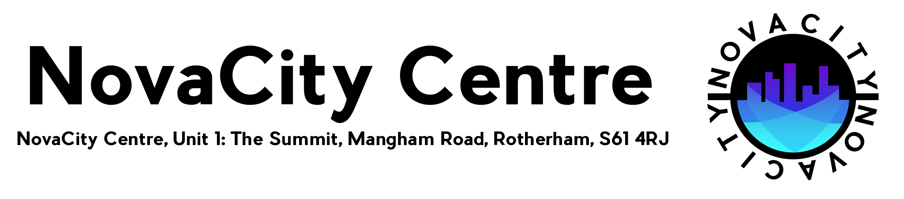

Nova City Alternative Provision Consent Form
What we need your information for and how we will use it.
- We collect and record information about you and your family to understand what help or service you might need.
- To help us plan the service we offer you.
- We may also use your information to improve the way we support families in the future.
- Sometimes, we also need to tell organisations that are funding us, how their money is helping people and your information could be used in that way too
Consent:
You are being asked to give your permission for personal information to be shared between Nova City Alternative Provision and other agencies where it is appropriate to do so.
There may be times we share your information without your consent:
• When require by law
• To protect a child or adult from harm
• To reduce and or prevent antisocial behavior, crime, and disorder
Your agreement:
We understand why information about our family is being recorded, how it was to be used and shared, with which other bodies and why. We agree that our information can be used and shared in this way to provide support to our family, to study how well the services offered meet our needs, to develop future policy, to train staff and further improve the services offered.
NovaCity is also an urban sports facility, where students may be involved in participating in Urban Sports. Therefore this form will also act as a waiver form, in acknowledgement you are aware of the activities in which the student will be untaken, and consent for the student to take part in such activity at their own risk.
We also may require to take your child off site on educational trips. All trips will be fully risk assessed before doing so.

Signature: Signature:
Name: Name:
Date: Date:

